12. Create a new NotebookLM project titled: <My Chapter Revision Notes.=
a) Upload multiple sources (any 2) such as:
i. PDF notes ii. Web articles iii. Text copied into NotebookLM b) Ask NotebookLM to:
- Create a combined study guide using all sources.
- Generate flashcards for quick revision. iii. Create a concept map or explanation of the topic. c) Manually check for:
12
i. Any incorrect facts ii. Repeated information iii. Missing important points
d) Attach 3 screenshots from NotebookLM:
i. Combined study guide ii. Flashcards
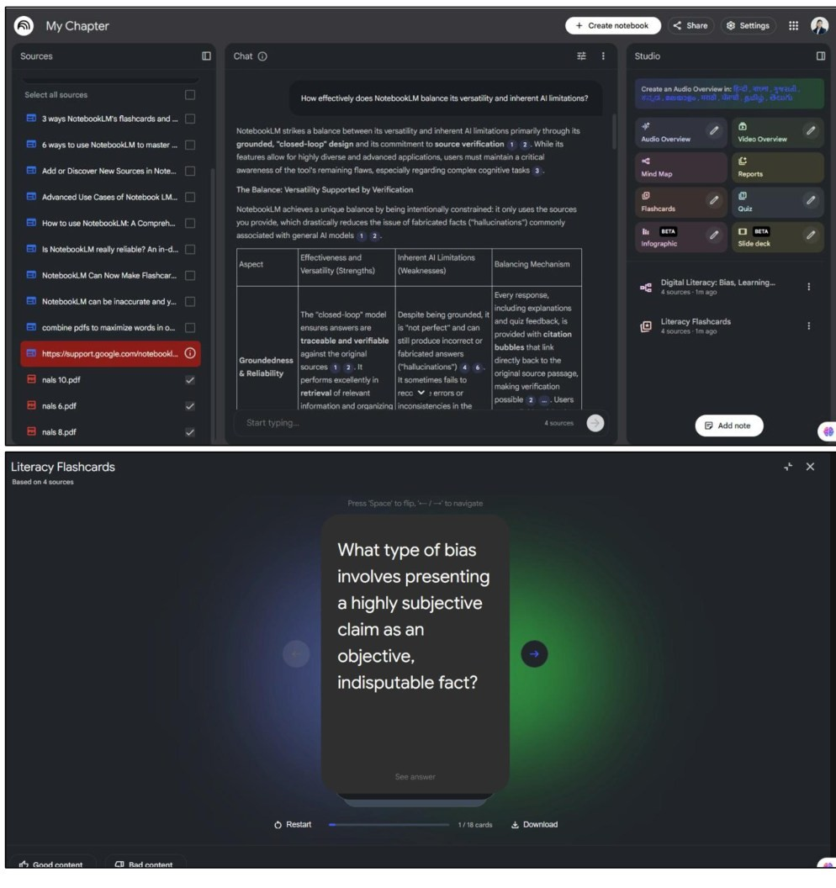
iii. Concept map / explanation
